# Web Banner 1

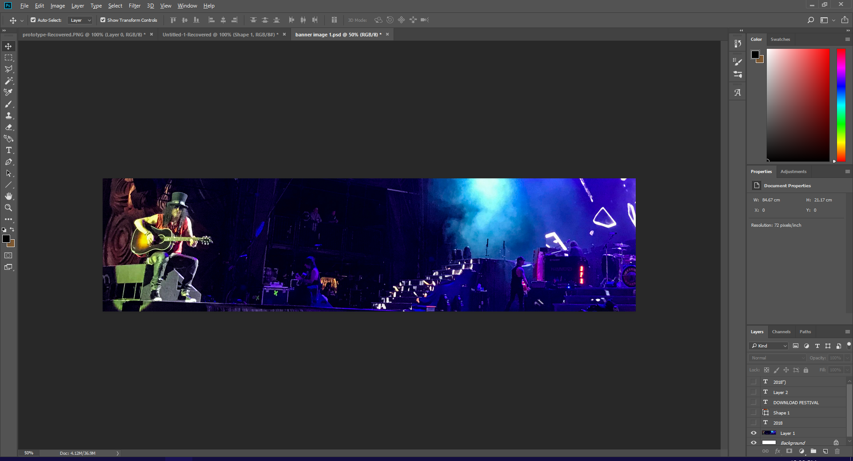

I started off my first banner by importing the image I will be using for the banner. This particular image contains the famous guitarist, Shash. The idea is that this will draw the viewer into the festival as they can see that famous guitarists have played there before. This shows the audience that this isn’t some little festival, and that its big and important and you should go.

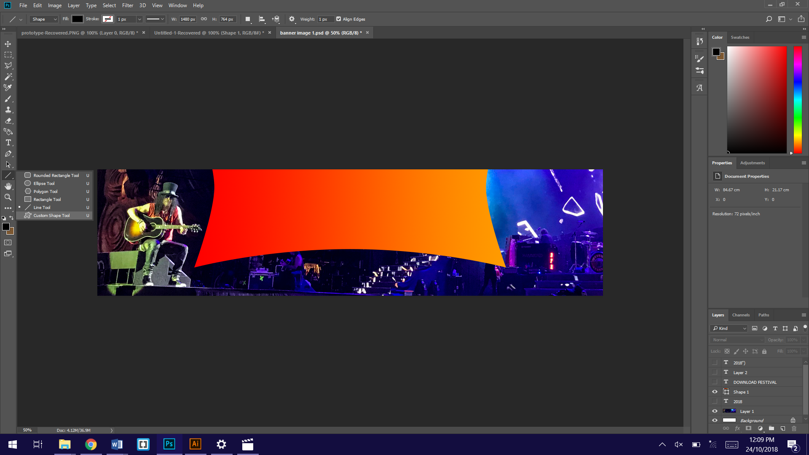

Next I added a custom shape. I went to the shapes tool on the left and held left click on it. I then chose custom shapes.

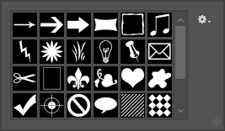

I chose the shape that I needed for my banner from the selection that appeared at the top once I selected the tool.

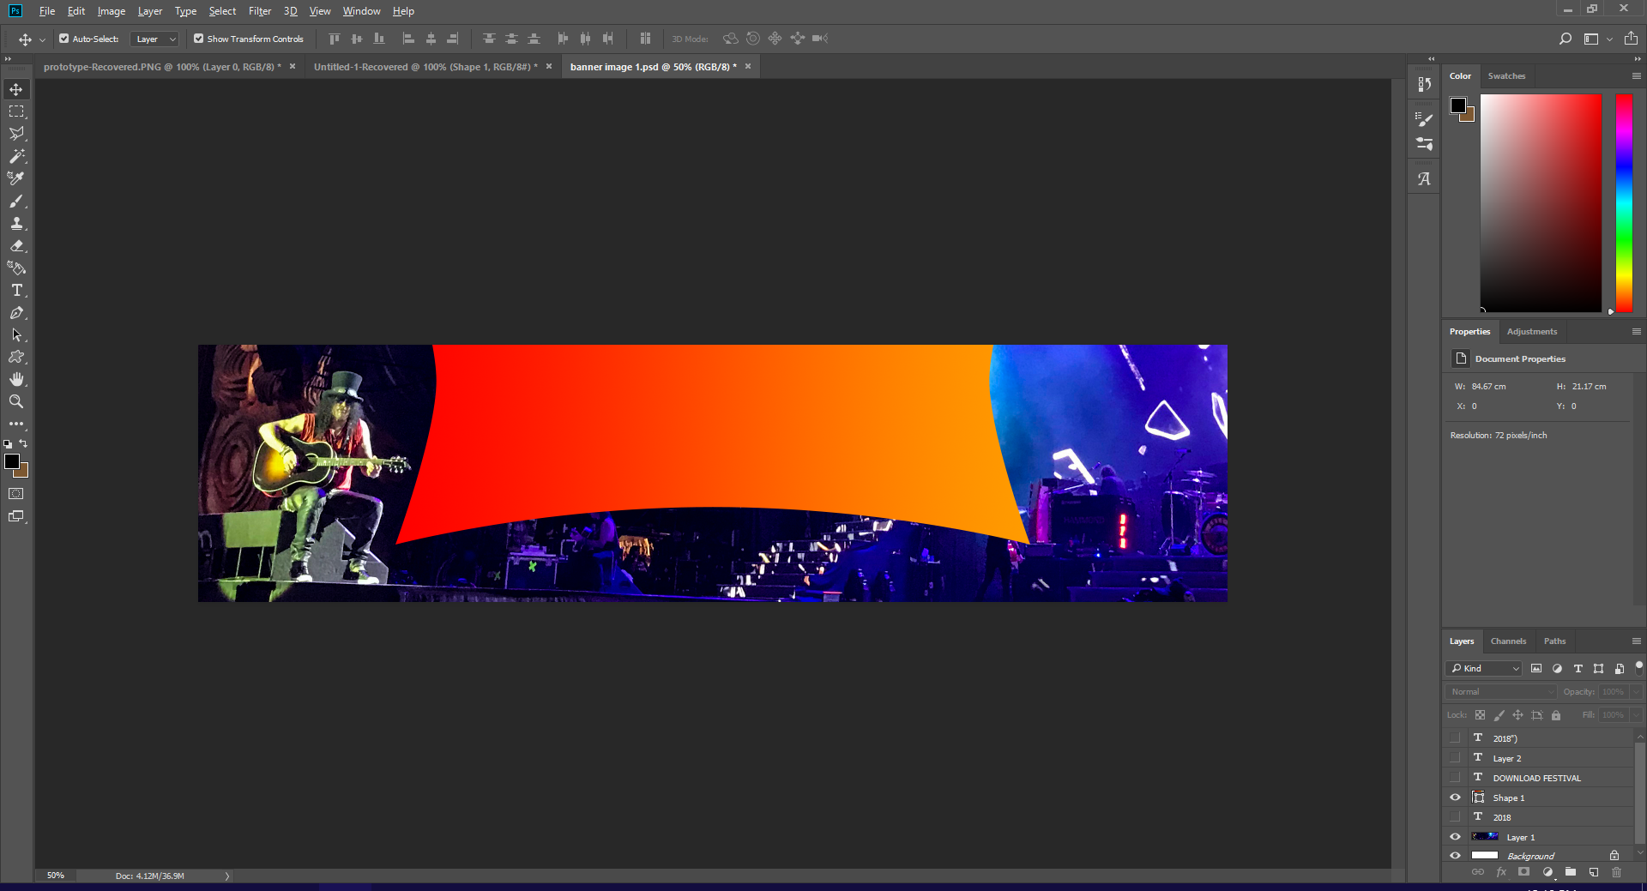

By dragging my mouse across the screen when holding left click, the shape was created. after creating the shape, I centered it on the workspace by dragging the shape with my mouse until it locked onto the centre of the space.

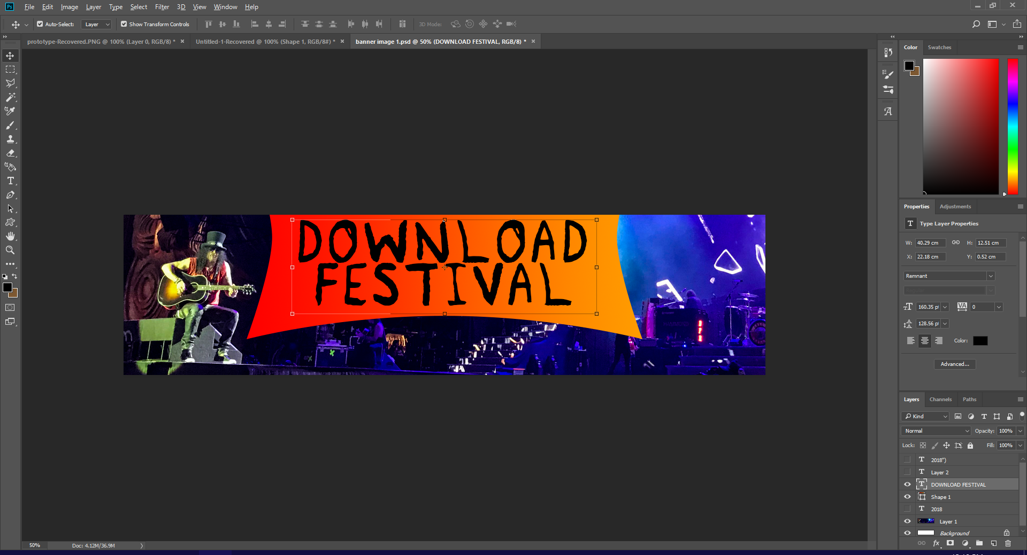

I then used the text tool to write out what I wanted the banner to say. In this case, I wanted it to say the name of the festival. I chose black for the text as it contrasted well with the orange and red gradient background. white also would have worked well, but I chose black as I knew I was going to use white for the next part of the text which wouldn’t be in the shape, and I wanted the name to contrast with the year.

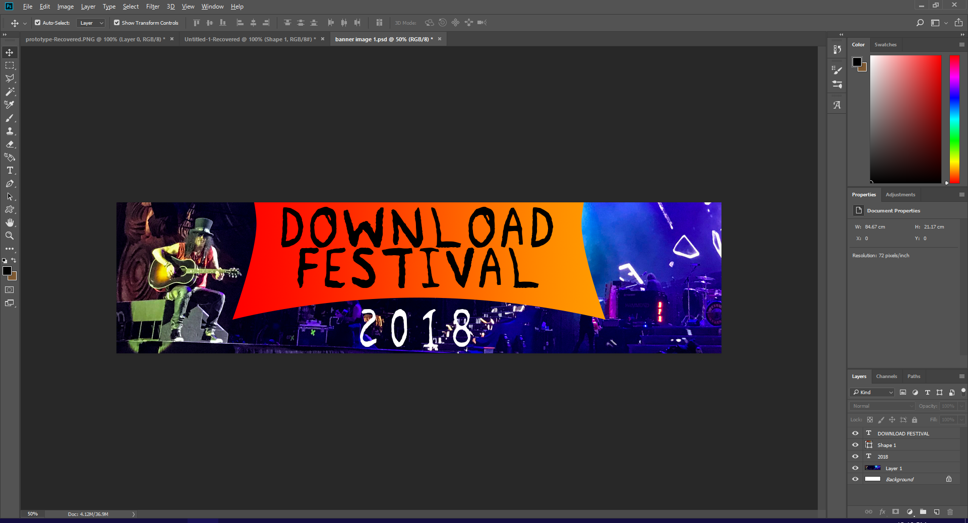

I then created the text outside of the shape and coloured it white. This text needed to be white in order to be able to read it against the dark background, because if the text was black then it would be barley legible.

# Web banner 2

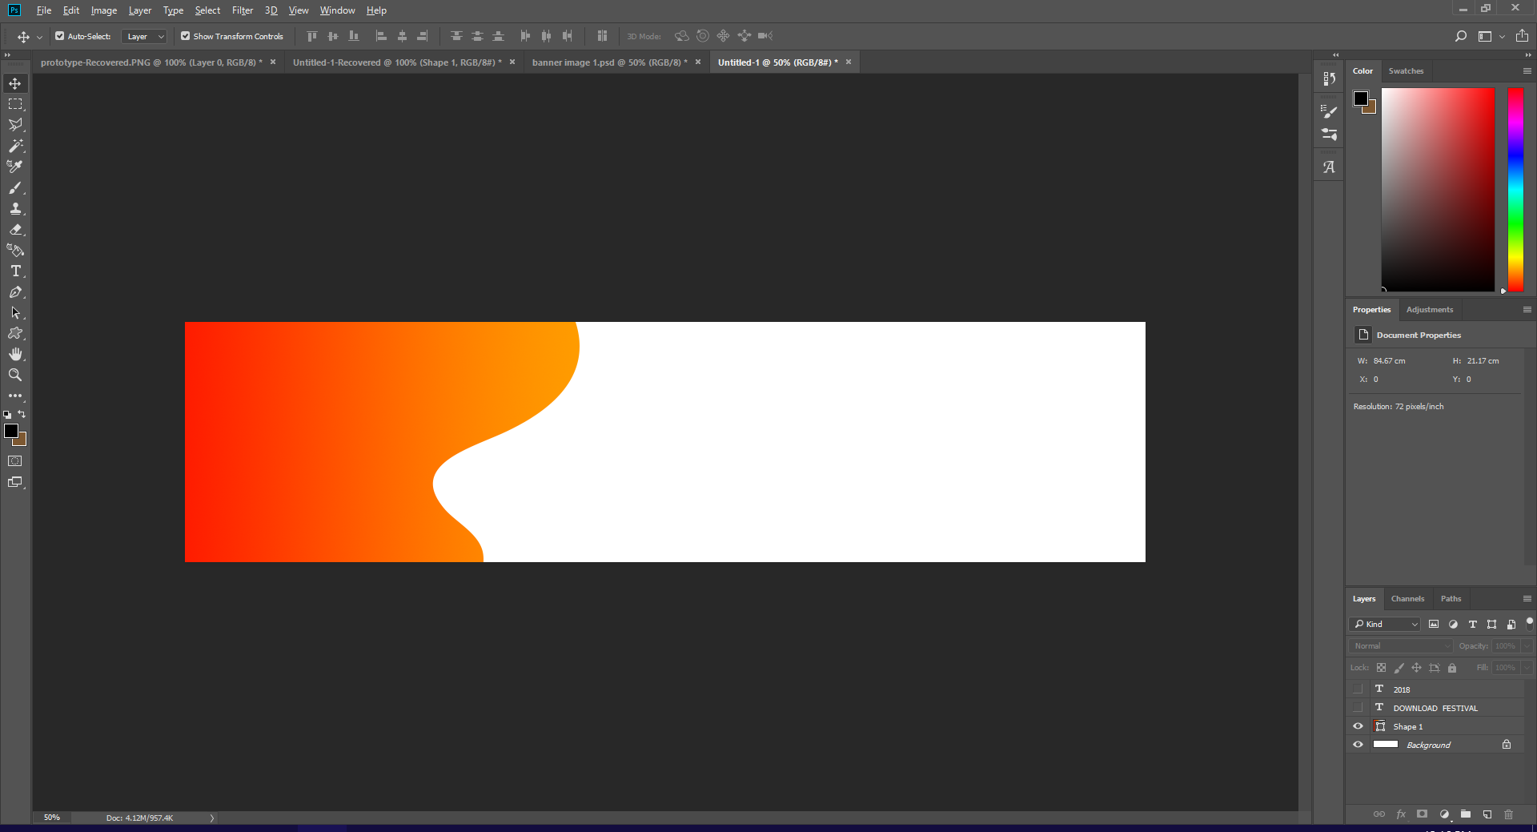

For this design I started off with another custom shape, but when greated with the tab shown in the previous banner, I chose the shape that looked like a paint spatter. I then enlarged it and shifted it off to the edge so only the side of it is shown. This space allows me to write the text, and not have it get in the way of the image. on top of this, the text chosen wouldn’t show up well on the image, as the image will finish off being black and white and the text is black.

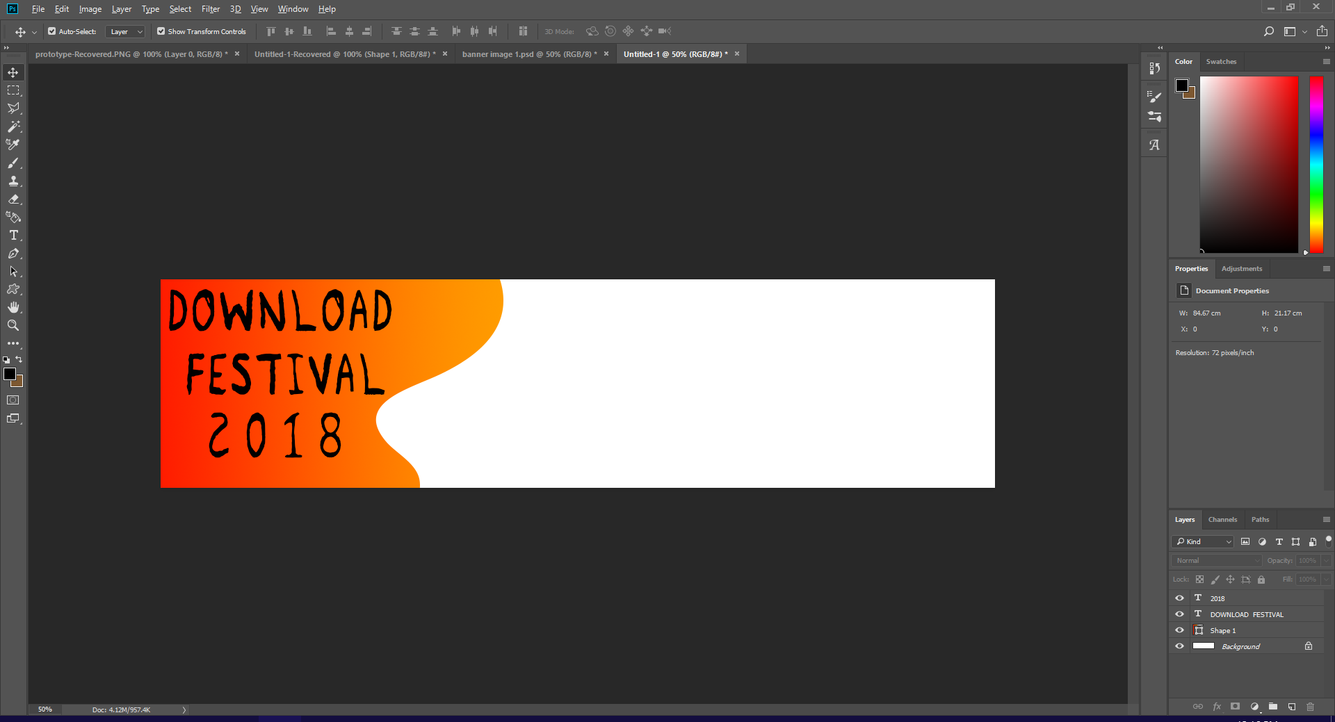

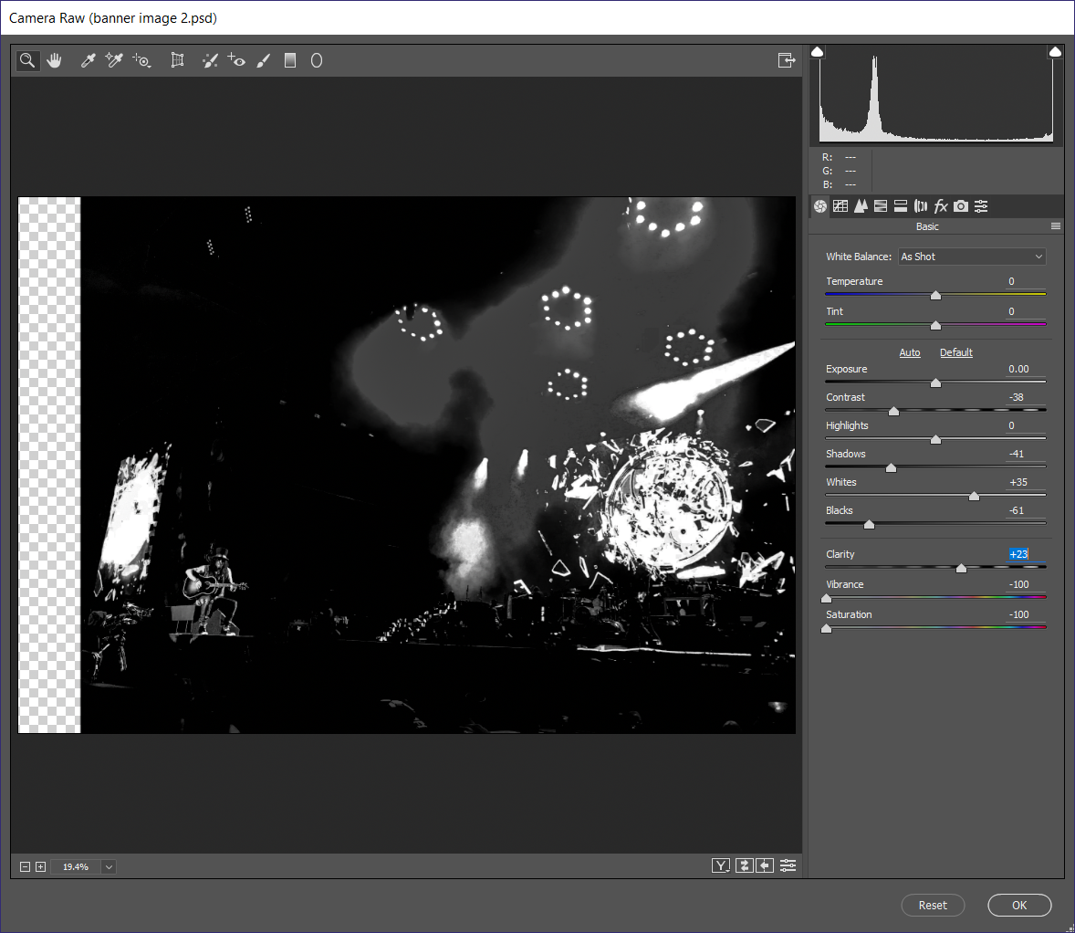

After importing the image I went into the camera raw filter settings. This allowed me to change the exposure, contrast, highlights, shadows, whites, blacks, clarity, vibrance and saturation. I used these settings to make the image black and white, giving it greater contrast against the shape on the left. I also increased the blacks and whites to increase the contrast, making the image look better.

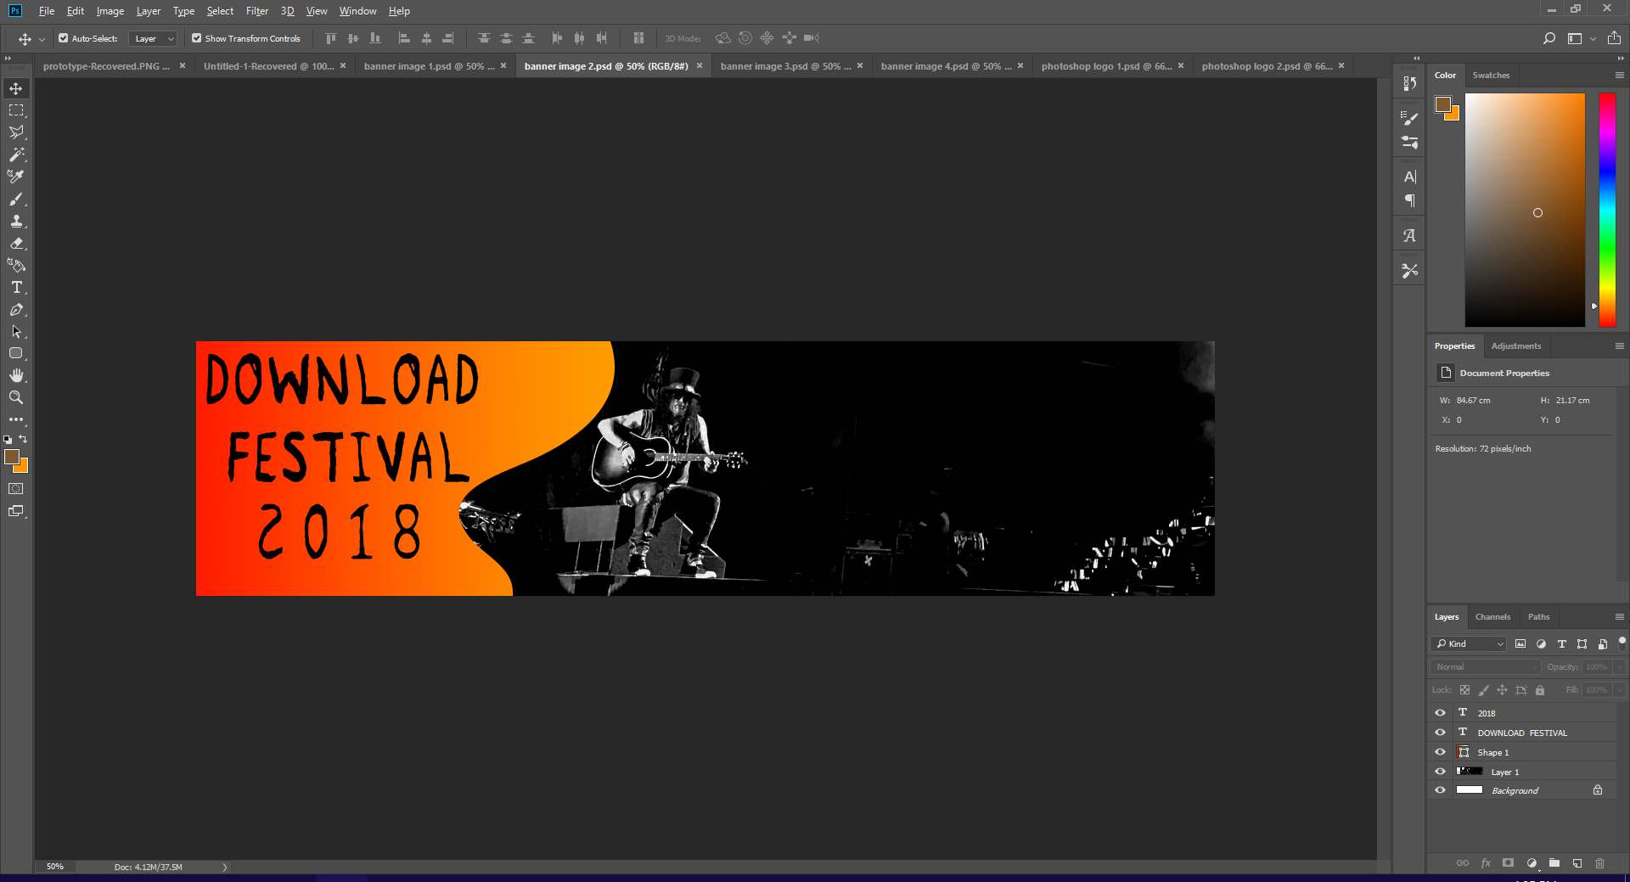

Here is the final banner image (a larger version will be shown at the end.

# Web Banner 3

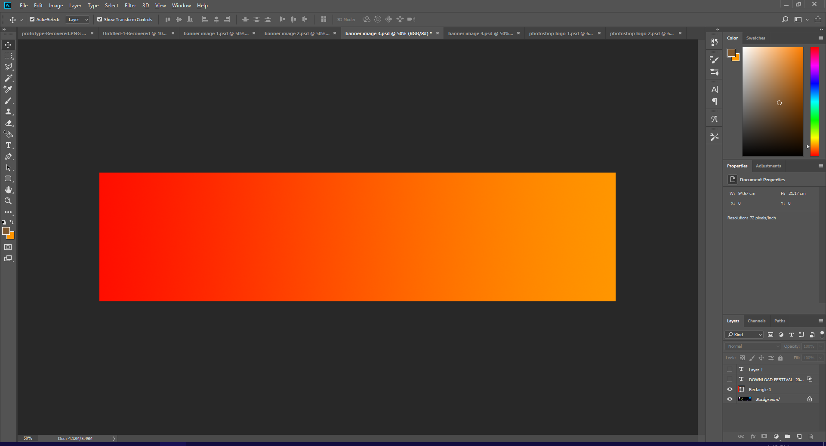

First, I started with creating a rectangle to act as the background, and gave it a red to orange gradient, similar to that used on previous banners, logos and icons. This is done for continuity reasons, and shows the viewer that its linked to the other graphics created.

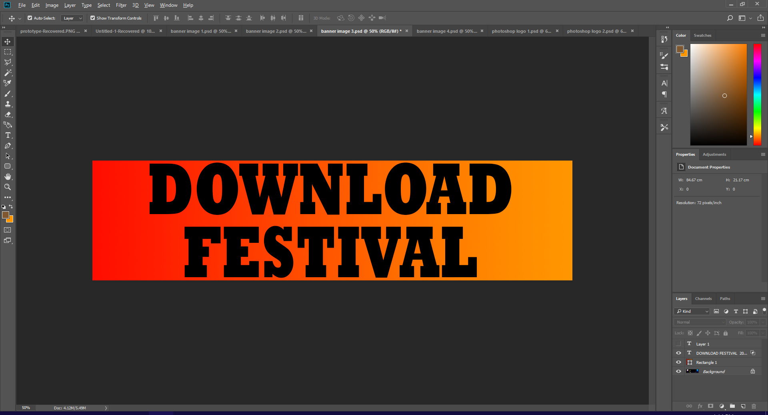

I then used the text tool to put the font onto the banner. I chose Rockwell bold as I think it suits the target audience better than some of the other fonts on photoshop, however its still not ideal for the target audience. It was also chosen because its get large fill letters, which means a more of the image will show through it than other fonts once the knockout effect has been applied.

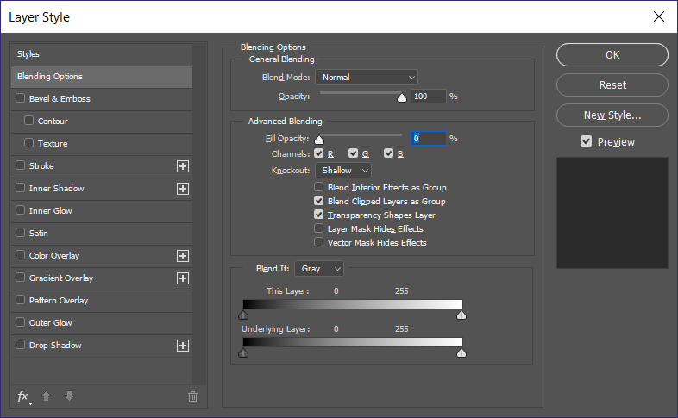

Much like on previous banners, I went into blending options, set knockout to shallow and set fill opacity to 0%. This created the desired knockout effect.

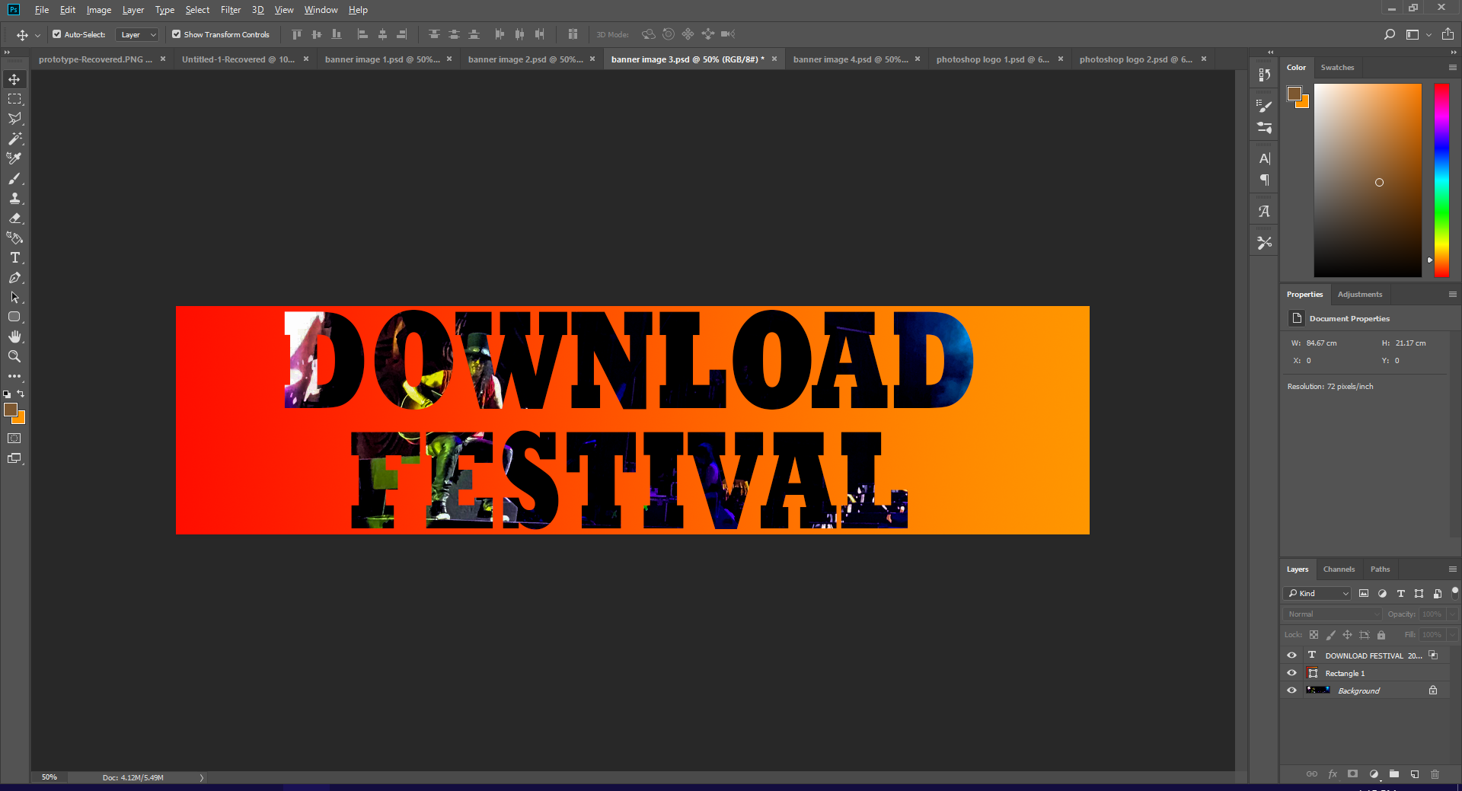

As you can see, the font has turned transparent and is creating a window through the rectangle so that we can see the image.

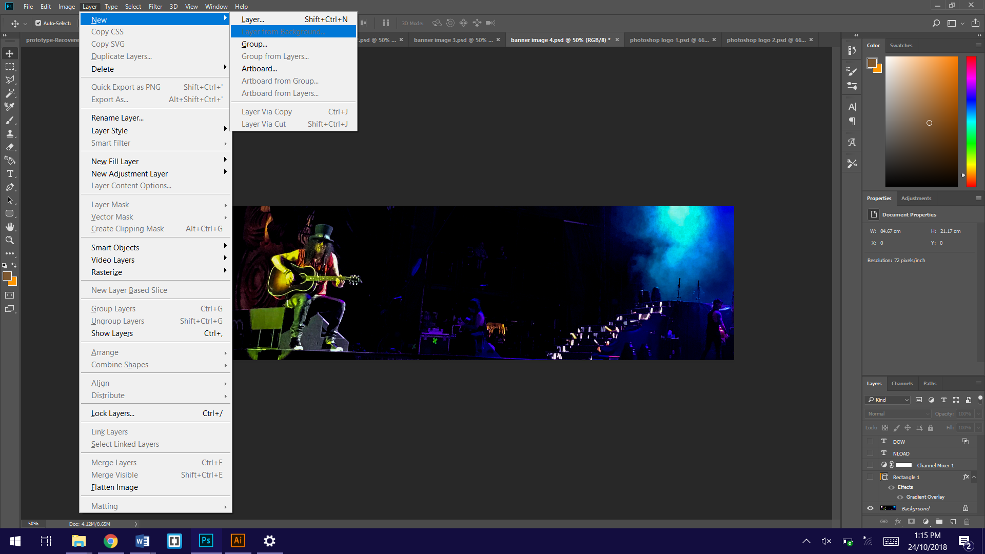

Sometimes I have issues with the knockout effect where all you can see through the knockout window is the transparent background texture. To fix this I go to layer > new > layer from background. this sets the selected layer as the background which means the knockout won’t cut through the image, but will show it.

# Web Banner 4

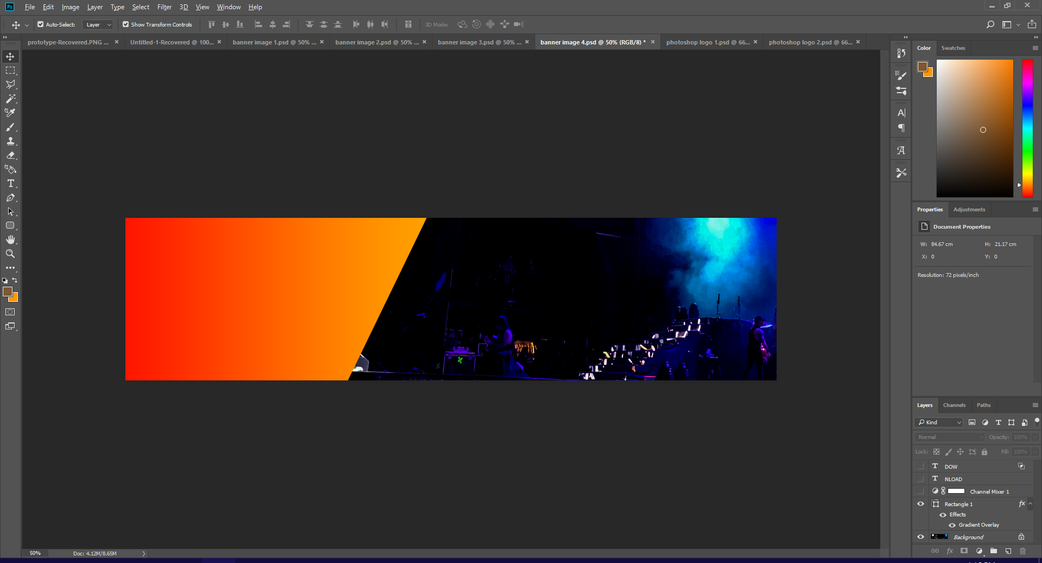

For the 4th banner, I started by creating a square. I then rotated the square and partially moved it outside of the project workspace to create this shape. I then gave the square a gradient so that the colours matched the ones on previous graphics

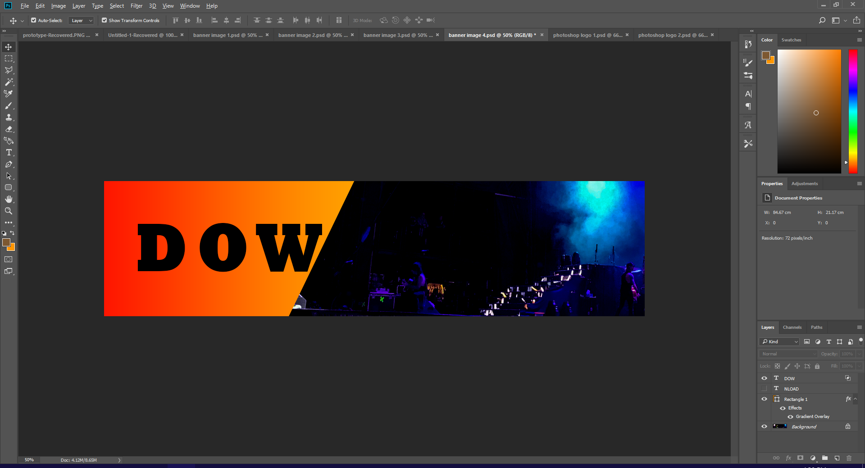

I then added the Letters “DOW” that will eventually make up the word Download. I made these words separate as they are the ones that are on the coloured shape, and are therefore going to be knocked out when the effect is applied. If I typed all of the letters in the same text box, then all of the letters would appear transparent and only the letters “DOW” would show. Therefore, I created the others separately so that they could be coloured white rather than transparent.

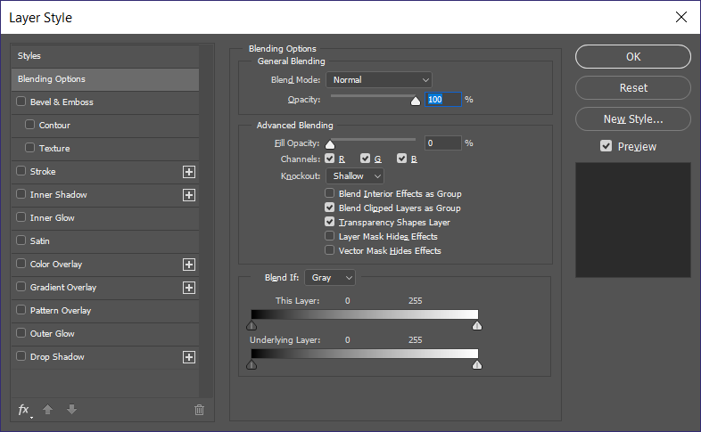

As usual for the knockout effect I went into blending options set fill opacity to 0% and set knockout to shallow.

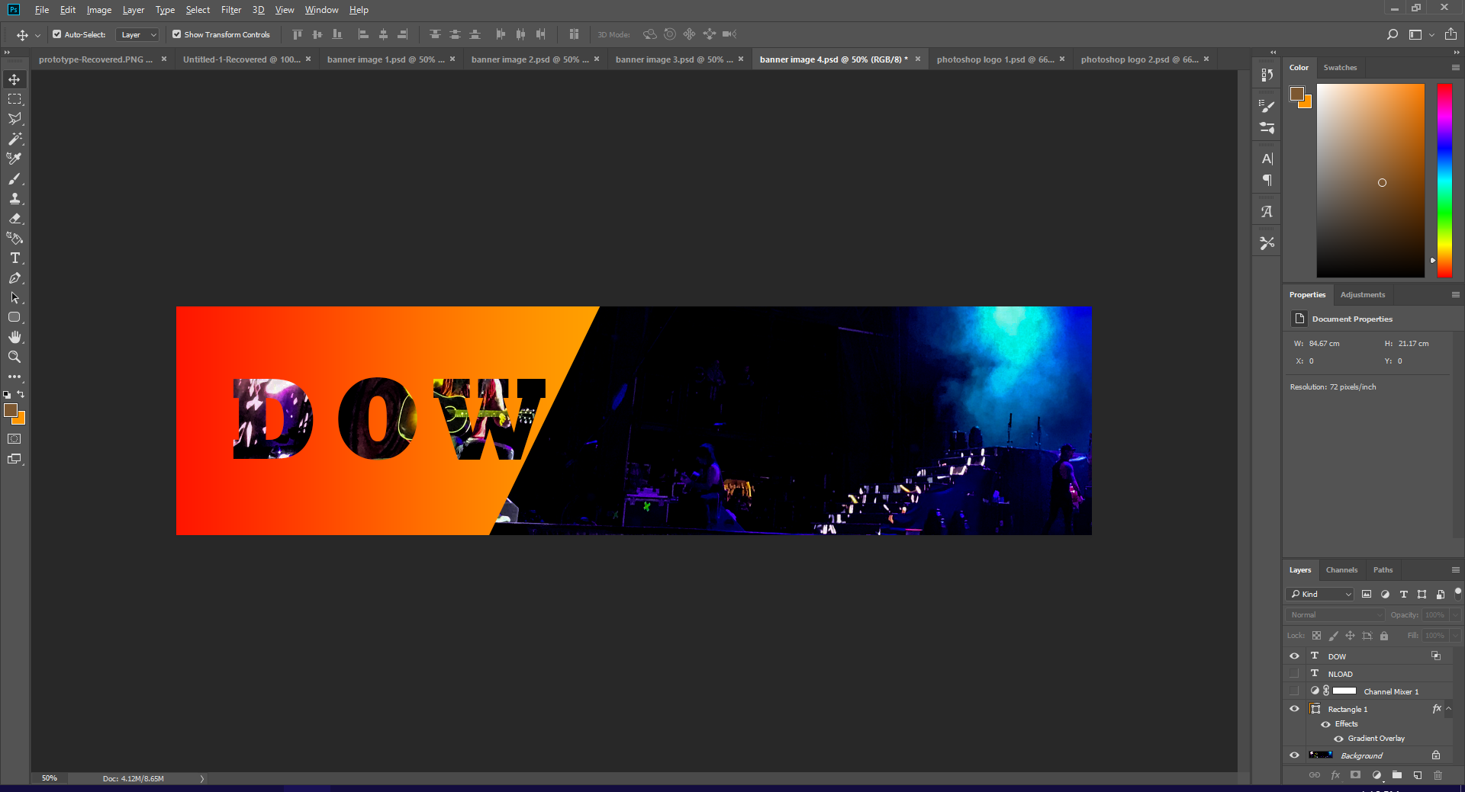

As usual, this created the desired knockout effect and allows us to see the image through the letters.

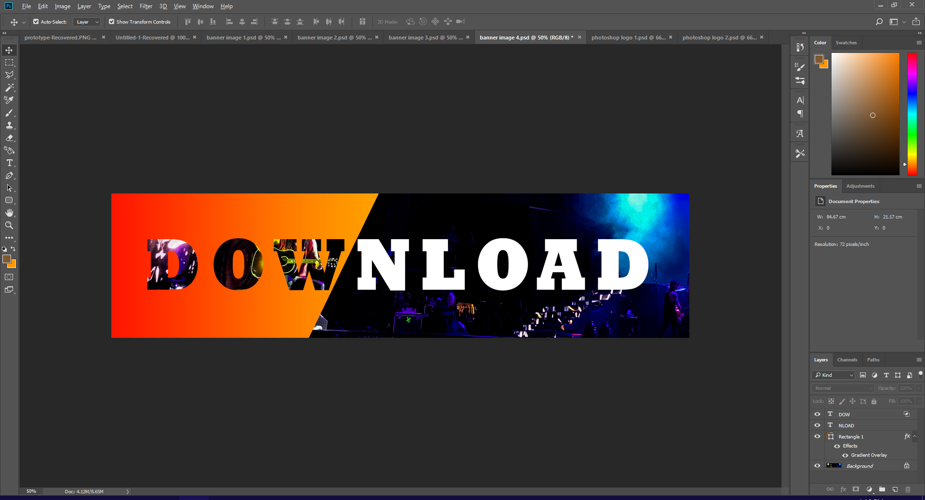

I then added the remaining letters to finish the word, and coloured them white so that they would show up at on the dark background.

# Web Banner 5

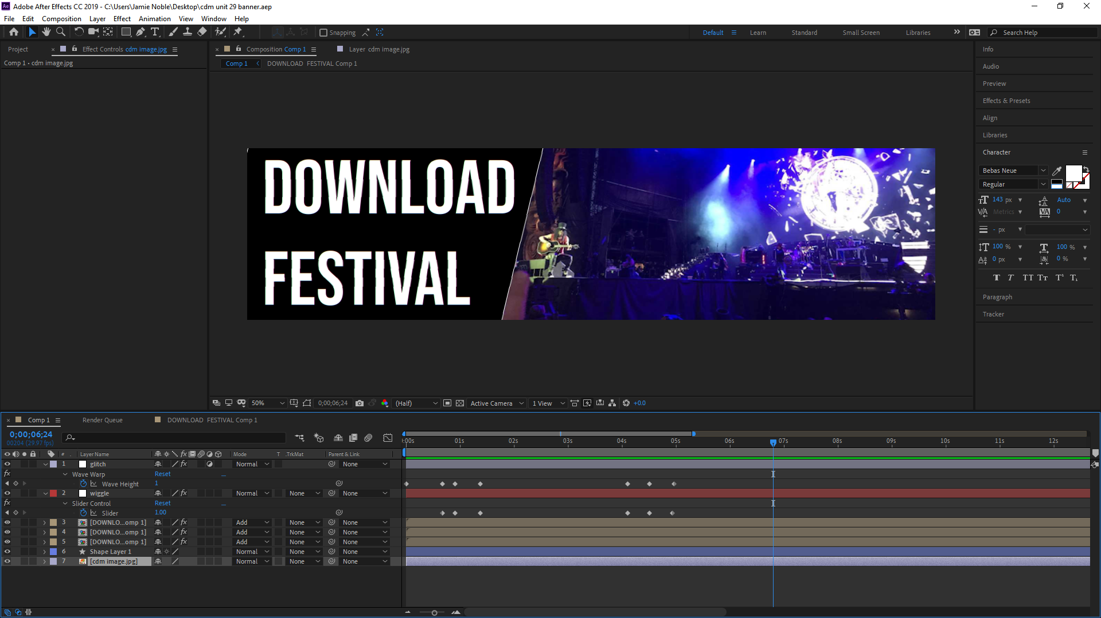

I created a fifth banner so that I could try and create an animated one. I created my fifth banner in Adobe after effects, where the previous 4 were created in Adobe photoshop. After effects allowed me to create an animated banner with graphical effects that are not possible in photoshop due to not being able to key frame or create animated graphics. On the timeline I created keyframes where certain things happen. At the start, the whole banner is slightly distorted and is gently wiggling/moving, but is still clear to read. about a second in the text becomes illegible and the text changes to the URL of the download website.

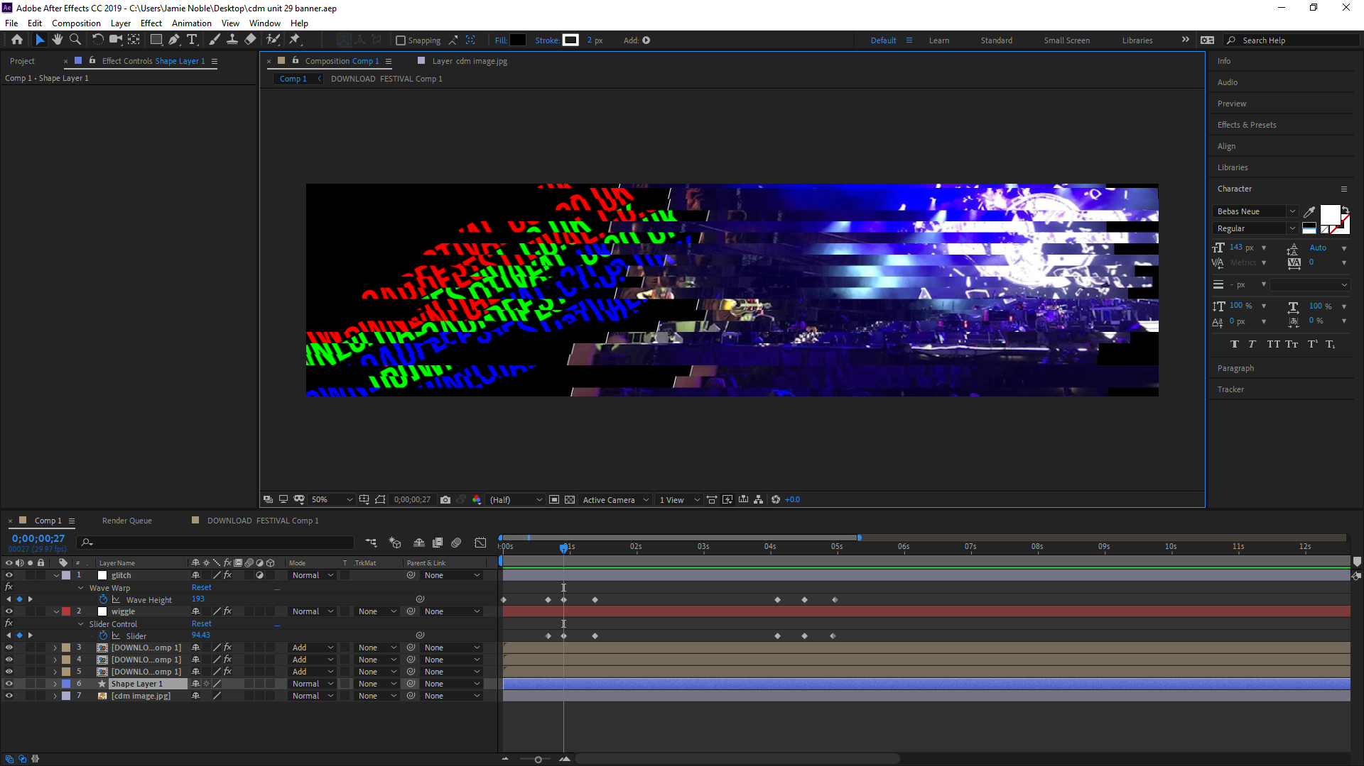

To do this there are three different versions of the text, one red, one blue and one green. They are all linked to a empty null which is set to move on those keyframes. Therefore, they all move together and create a distorted/glitch effect. The text changes at the moment the text is the most hard to read. although the content of the text changes, because the text has been pre composed it means that the text can be changed without having to create another 3 versions of the second text, as you can double click on one of the texts in the timeline and it will take you to a second page, where you can change the content of the text at the desired time without editing the rest of the project.

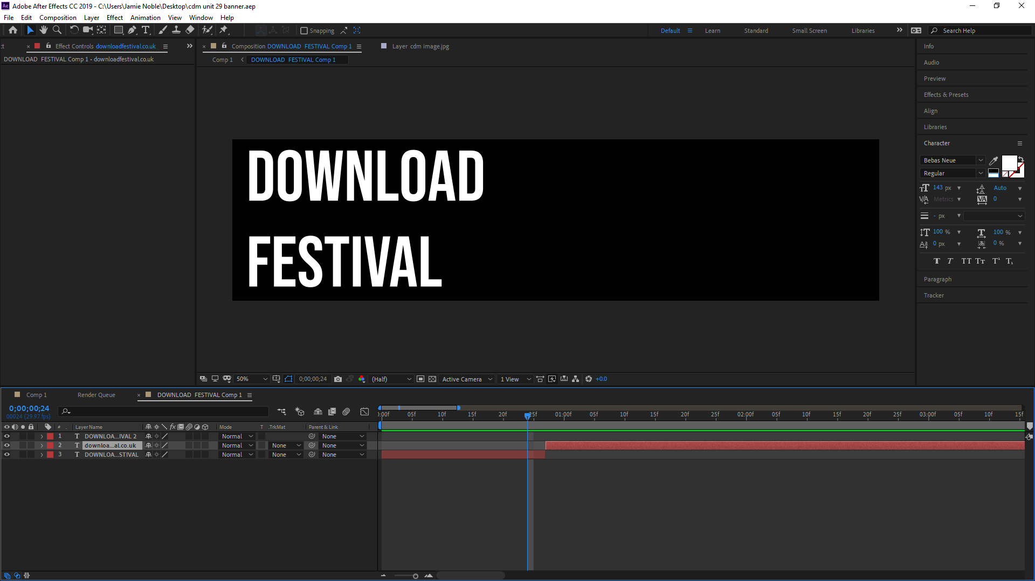

In this menu you can slice the layer and change it, meaning the effect of the splitting colours will happen but wont effect the actual layer.

The animation is set so it creates a perfect loop, so if it was displayed on a website or digital billboard it will infinitely loop, meaning the viewer will still be able to see the website link even if they missed it the first time, and the viewer won’t be able to notice that the video ended and looped.

The finished animation will be linked.